PRE K Supply List
Mrs. Lucas (Lead Teacher) & Ms. Greene (Teaching Assistant)
2024- 2025
Personal Items:
Backpack (Large enough to hold a folder and a blanket)
Small blanket for Rest Time (please make sure it can fit folded in child’s bookbag)
Spare Clothes- Child’s name on each piece
Child’s Headphones (OVER THE EARS, NOT EARBUDS)
KinderMat (1 inch red and blue preferred)

Refillable Water Bottle- Labeled with child’s name

Classroom Supplies:

2 boxes of 24 count Crayons

6 count Glue Sticks

1 pack of dry erase markers- BLACK INK

12 count Pack of Colored Pencils

Primary Composition Notebook- It will have a space to draw and a space to write

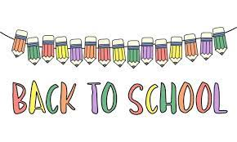
Pencil Box
Wish List:

These items are greatly appreciated as we use all of them each and every day for all of the students 😊

Paper Towels
Clorox Wipes
Baby Wipes
Kleenex
Hand sanitizer
Gallon Ziplock Bags
Quart Ziplock Bags

